SSL VPN Configuration Documentation

3. HQ FortiGate SSL VPN Configuration

Step 1: SSL VPN Settings
Navigate to VPN → SSL-VPN Settings
Configuration:
- Listen on Interface: port2 (LAN)
- Listen on Port: 10443 (HTTPS)
- Server Certificate: Fortinet_Factory
- Idle Timeout: 3000 seconds
- Tunnel Mode IP Pools: SSLVPN_TUNNEL_ADDR1 (10.212.134.200 - 10.212.134.210)
- IPv6 Pools: SSLVPN_TUNNEL_IPv6_ADDR1 (fdff:ffff::/120)
- Default Portal: full-access
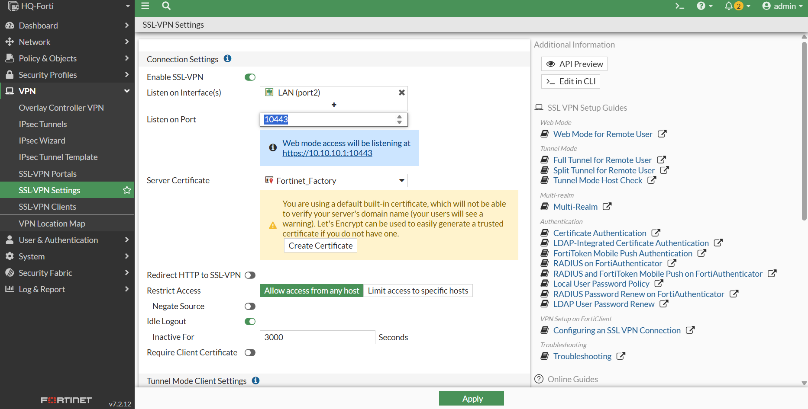

Portal Settings (full-access):
- Tunnel Mode: Enabled
- IPv6 Tunnel Mode: Enabled
- Web Mode: Enabled
- IP Pools: SSLVPN_TUNNEL_ADDR1
- IPv6 Pools: SSLVPN_TUNNEL_IPv6_ADDR1
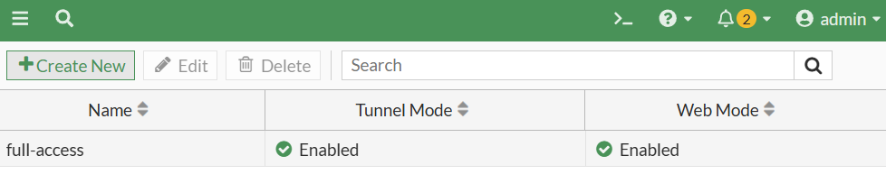

Step 2: Create IP Pool for SSL VPN Users
Navigate to Policy & Objects → Addresses
Create New IP Pool:
- Name: SSLVPN_TUNNEL_ADDR1
- Type: IP Range
- Start IP: 10.212.134.200
- End IP: 10.212.134.210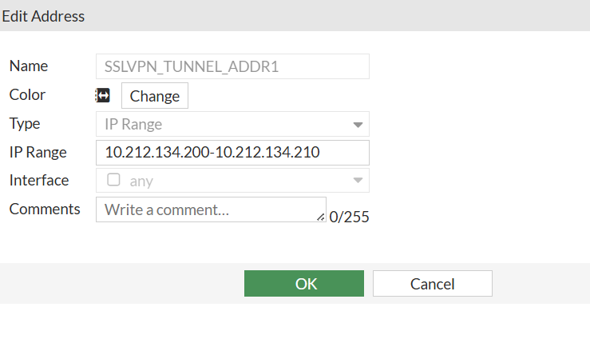

Step 3: Create User Account
Navigate to User & Authentication → User Definition
Create New User:
- Username: vpnuser
- Type: Local User
- Password: (Set secure password)
- Status: Enabled
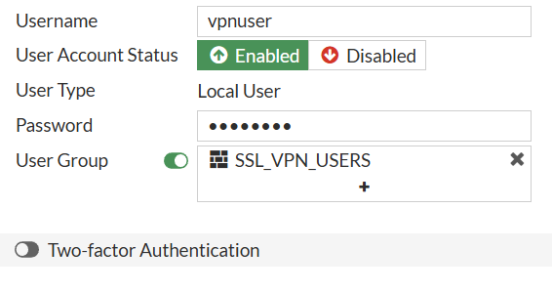

Step 4: Create User Group
Navigate to User & Authentication → User Groups
Create New Group:
- Name: SSL_VPN_USERS
- Type: Firewall
- Members: vpnuser
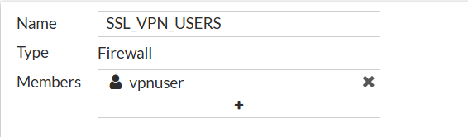

Step 5: Firewall Policy Configuration
SSL VPN Access Policy
Navigate to Policy & Objects → Firewall Policy
Policy Details:
- Name: SSL_VPN_Access
- Incoming Interface: SSL_VPN tunnel interface (ssl.root)
- Outgoing Interface: LAN (port2)
- Source: SSLVPN_TUNNEL_ADDR1
- Destination: all
- Schedule: always
- Service: ALL
- Action: ACCEPT
- NAT: Enabled (Use Outgoing Interface Address)
- Security Profiles: AntiVirus, Web Filter enabled

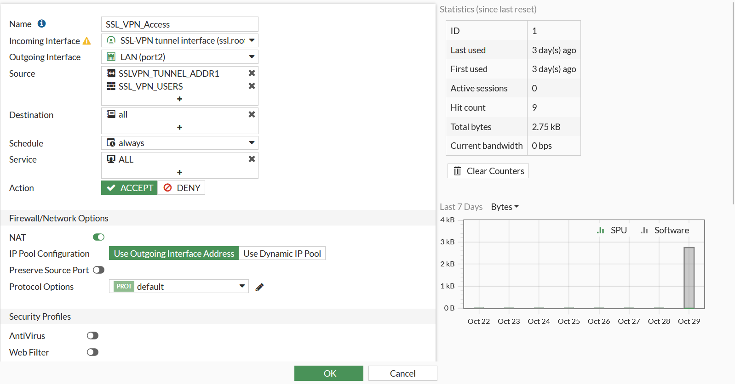

Step 6: Web-Based Mode Testing
Test 5.1: SSL VPN Portal Access Test
Verify web portal accessibility and authentication
- SSL-VPN portal accessible at https://192.168.32.135:10443 or <ip:port>
- Portal shows: "The SSL-VPN portal has been enabled for tunnel mode use only"
- FortiClient launch and download options available
- Connection history visible with previous sessions
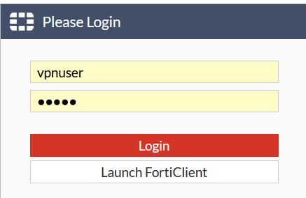
Test 5.2: Web Portal Services Test
Test web-accessible services through portal
- Access to the VPN target
- Then login as a vpnuser
- View the details
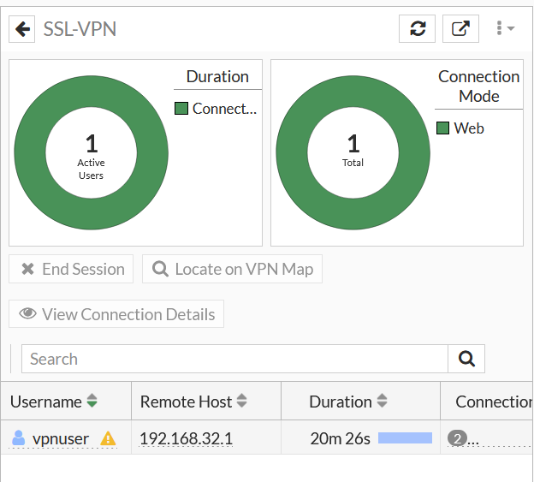
- Verify login from the fortigate firewall GUI (Dashboard → Network)
- See the details to view that its web mode access on the SSL VPN
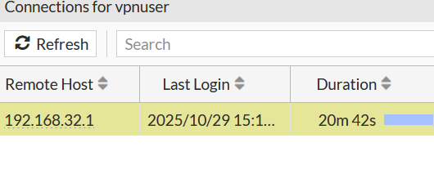

Step 7: FortiGate SSL VPN tunnel mode test
FortiClient Connection configuration
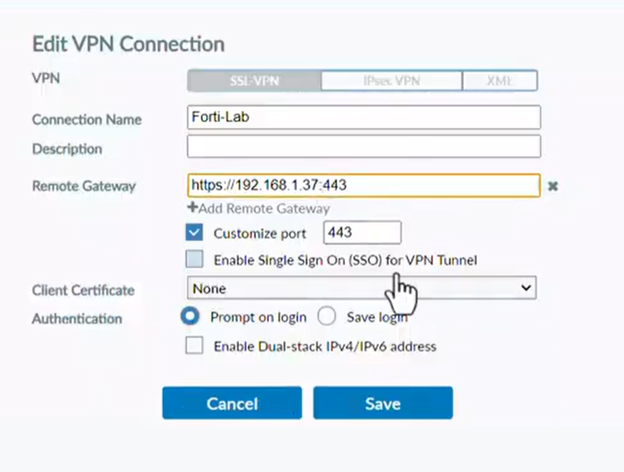
VPN Connection Settings
Connection Parameters:
- VPN Name:
- Connection Type: SSL-VPN
- Remote Gateway: https://<IP>:10443
- Custom Port: 10443
- Authentication: Username/Password
- Username: vpnuser
- Single Sign-On: Disabled
- Client Certificate: None
- Dual-stack IPv4/IPv6: Enabled

Step 8: connection and monitoring
In this step, after establishing the connection using tunnel mode, I selected Forti-Lab and tested the setup using the VPN user I had previously created.
As shown in the image, the monitoring interface displays several key details for each connected user:
- Username – identifies the authenticated VPN user.
- IP Address – shows the assigned IP for the VPN session.
- Connection Duration – indicates how long the user has been connected.
- Bytes Sent and Received – displays the amount of data transmitted during the session.
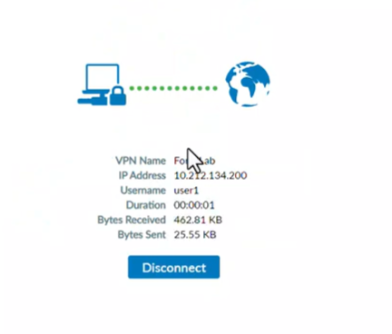

Step 9: Monitoring and Troubleshooting
Active Connections Monitoring
SSL-VPN Dashboard Shows:
- Active Users: 1
- Connection Mode: Web
- Username: vpnuser
- Remote Host: 192.168.1.9
- Tunnel Ip: 10.212.134.200
- Duration: 44s
- Source interface: Wan1
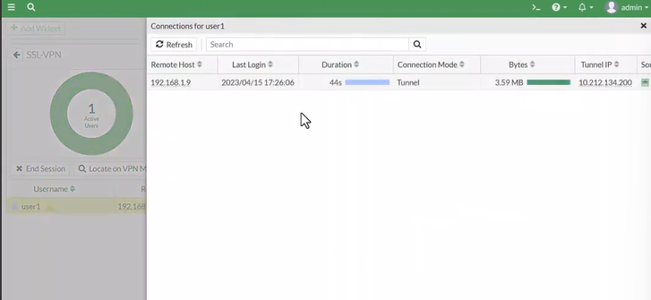
- Tunnel IP: Assigned from SSLVPN_TUNNEL_ADDR1 pool

Document Version: 1.0
Last Updated: October 28, 2025
FortiGate Version: 7.2.12
Tested With: FortiClient 7.2.12

